Welcome Gymnastics Parents,

We look forward to hosting the Dreamcatcher Gymnastics Invitational this year in Santa Fe. Attached are the session times so you can plan your visit. The competition venue is in the Santa Fe Convention Center at 201 Marcy Street.

Parking. There is a parking garage directly below the convention center if you are driving in for the meet. Rates are $2 per hour and $12 max per day. Parking on the street at a meter is FREE on Sundays (but not the parking garage)

If you are staying at the Hilton, the Convention Center is a two block walk.

Food will be available at the Convention Center from our food vendor What-The-Truck all weekend long.

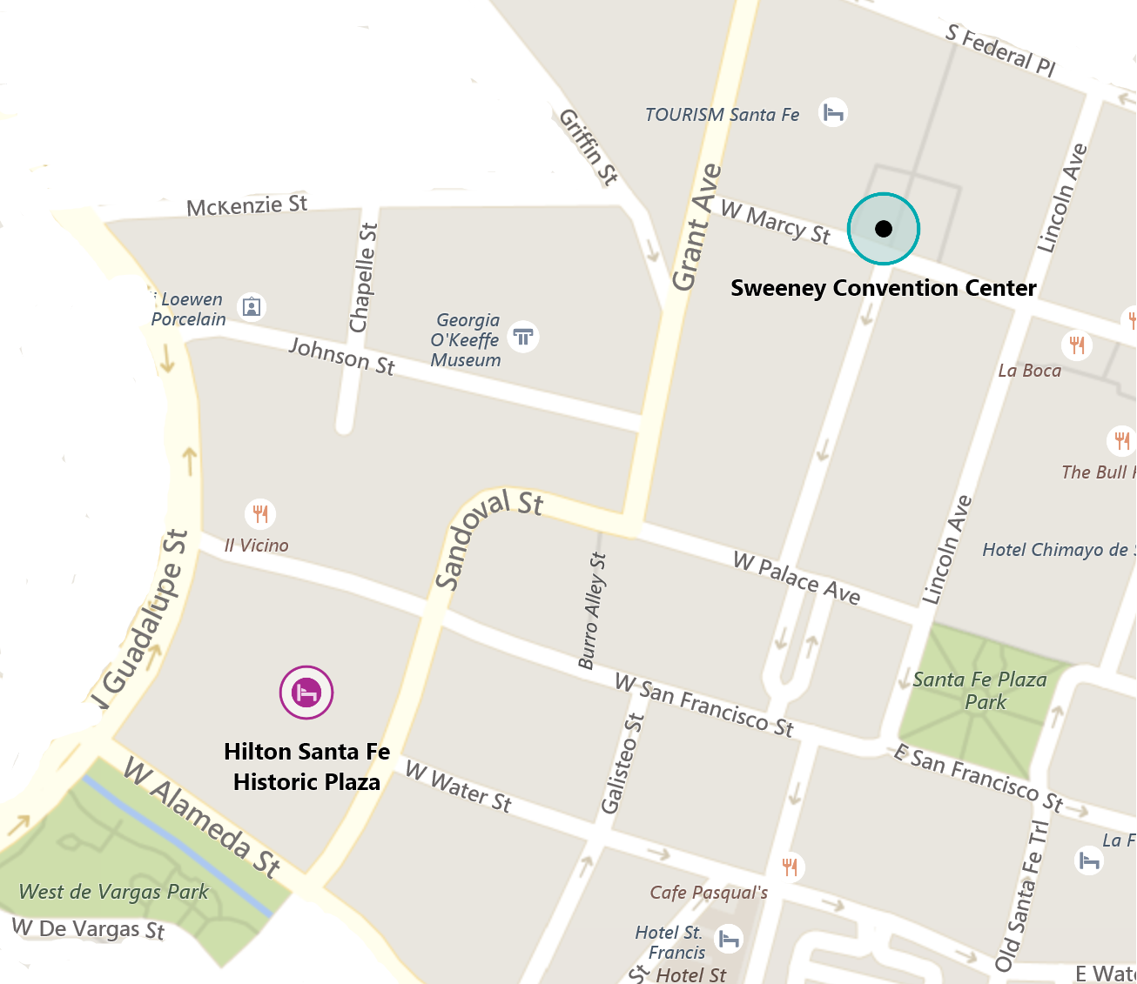

Walk outside of the Hilton and go left on Sandoval St. This will curve right for half a block. Then turn left on Grant Ave and go for a block. Convention center entrance is on the corner of Grant Ave and W Marcy St. Should be a 7 minute walk.

Prior to morning sessions, Hilton has a breakfast buffet. There are many famous restaurants, shops, art gallies and museums in the downtown Santa Fe area. Enjoy your weekend.

Check out the famous Canyon Road for art displays, or try Meow Wolf for interactive Sci Fi tour.

Admissions for spectators is

$20 adult all day

$10 kids 5-12 all day

$0 kids 0-4

$35 adult all weekend

$15 kids 5-12 all weekend

$5 Discount for Seniors and Active Military