

 | The 25th Annual  Black Diamond Gymnastics Winter Classic  February 20-22, 2025
Dear Athletes and Families,

We are thrilled to welcome you and your teams to the Annual Winter Classic meet, hosted by Black Diamond Gymnastics in Utah. We appreciate your participation and can’t wait for an exciting competition filled with incredible talent, sportsmanship, and fun.

Below, you’ll find all the key information to help make your visit smooth and enjoyable.

NOTE: Open workout is available Thursday, 7:00 pm – 9:00 for traveling athletes, level 7 and up.
- Coaches must be present in order for your athlete to be on the floor.
- Coaches and athletes should check in together at the athlete check in table (in the lobby outside of the Hall 5 main entry doors at the 300 West entrance) starting at 6:30 pm.
- Parents permitted only with paid wristband.

See you soon, and best of luck to you!

Event Location
Salt Palace Convention Center – Hall 5
- The convention center is very large and there are multiple entrances. Click here to view a map.
- Watch for directional signage throughout the venue, including these floor stickers to indicate which direction to walk:
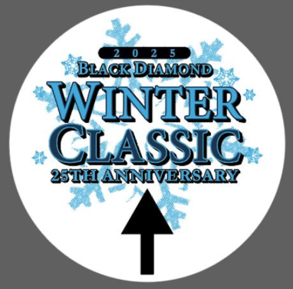

Getting to the Venue & Parking
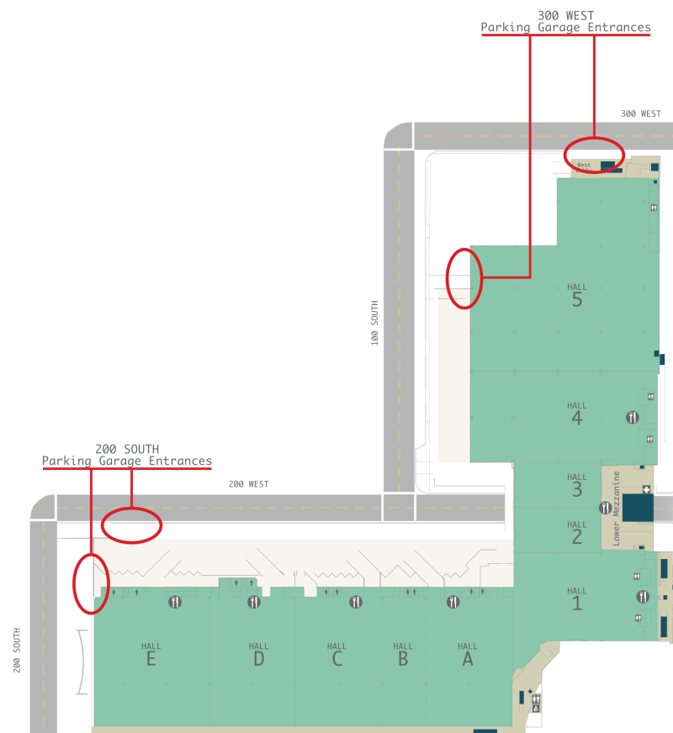 | The most convenient parking will be in the 300 West Lot  ←  Two Entrances:  - Enter off of 300 West between 100 South and South Temple  - Enter off of 100 South between 200 West just past the Japanese Garden

For additional parking information, visit the Salt Palace Convention Center website HERE.

Public transit is available via Trax:
- To get to the Delta Center in Salt Lake City, Utah using the UTA TRAX, you can take the TRAX Blue Line or Green Line to the Arena Station.
- The Arena Station is located at 301 West South Temple, across from the Delta Center.

Check-in & Admissions
Entry to Hall 5 will only be accessible at the 300 West end of the building.

- Spectator Admissions – When looking at the Hall 5 entry doors from the 300 West entrance, Artistic spectator admissions will be just inside the main doors.
- Athlete check-in – Will be in the lobby area (outside of the entry doors for Hall 5 at the 300 West entrance).

If you are walking from entrances other than the 300 West exterior entry point, you will come to Halls 3 & 4 before reaching Hall 5. Please note there is a separate event taking place in those halls.

Hours of Entry
- Doors will open 45 minutes prior to the first session of each day
- Doors will close 45 minutes after the last session of the day

Check-In & Credentials

Athlete Check-In:
- All athletes must check in at the athlete table and receive their button.
- Please instruct athletes to place their button on their warmup jacket, or on a backpack so they can quickly and easily be identified by event staff.
- Athletes must have their button with them to re-enter Hall 5 if they leave for any reason.
- Gymnasts should arrive at least 45 minutes before their session / flight time.
- Advise your gymnasts to arrive in their team leotards/warm-ups. There is no dedicated changing area separate from the public restroom.

Spectator Admissions:

Adults  $25 / session  $25 / finals  $50 / weekend VIP pass (all access Thu, Fri, and Sat – includes finals) | Kids 3-12  Free / up to age 2  $20 / session  $20 / finals  $40 / weekend VIP pass (all access Thu, Fri, and Sat – includes finals) | Seniors 55+  $20 / session  $20 / finals  $40 / weekend VIP pass (all access Thu, Fri, and Sat – includes finals)

Payment Methods: Cash (exact change appreciated) and debit / credit card

Neither Black Diamond Gymnastics nor the Salt Palace Convention Center can be held responsible for any lost or stolen items. Please do not leave personal or team items unattended at any time.

Inside the Event

Concessions
- There will be a few options available inside of Hall 5, including:
  - Chile Verde
  - Rice Bowls & Bao Buns
  - Portable Coffee Bar
- Note that there may be other vendors open for business in other areas of the Salt Palace Convention Center, but we cannot guarantee times or availability. Please plan accordingly.
- Please advise all coaches, athletes, and families to bring spillproof water bottles.

Winter Classic Logo Apparel - Apparel Republic will be onsite offering customized apparel for purchase.

Leo Distribution - The Winter Classic leos will be distributed to coaches directly.

Awards
- There will be two awards stages – matched to the two gyms by color (one blue, one white).
- Awards will be presented immediately following each session.

Media - All athletes, coaches, and spectators entering the competition area should be aware that both action photos and videos may be taken during the event.

Things To Do in Salt Lake City and Beyond

Salt Lake City and the surrounding mountains offer a wide variety of things to do, see, and experience. Check out the VisitSaltLake.com site or click on the links below for information and special offers.

- Salt Lake Visitors Guide

- Salt Lake Restaurants

- Salt Lake Ski Super Pass

- The Salt Lake Connect Attractions Pass

- Salt Lake Brewery Pass

